WEEK 1

TASK 1: Introduction to Functional Programming Concepts
1A: Java Lambda Expressions
PROGRAM:
import java.io.*;
import java.util.*;
public class Solution {
interface PerformOperation {
boolean check(int a);
}
public static PerformOperation isOdd() {
return (a) -> a % 2 != 0;
}
public static PerformOperation isPrime() {
return (a) -> {
if (a < 2) {
return false;
}
for (int i = 2; i * i <= a; i++) {
if (a % i == 0) {
return false;
}}
return true;
};
}

public static PerformOperation isPalindrome() {
return (a) -> {
int original = a;
int reversed = 0;
while (a > 0) {
int digit = a % 10;
reversed = reversed * 10 + digit;
a = a / 10;
}
return original == reversed;
};
}
public static void main(String[] args) {
Scanner sc = new Scanner(System.in);
int T = sc.nextInt();
while (T-- > 0) {
int condition = sc.nextInt();
int number = sc.nextInt();
PerformOperation operation;
if (condition == 1) {
operation = isOdd();
if (operation.check(number)) {
System.out.println("ODD");
} else {
System.out.println("EVEN");
}

} else if (condition == 2) {
operation = isPrime();
if (operation.check(number)) {
System.out.println("PRIME");
} else {
System.out.println("COMPOSITE");
}
} else {
operation = isPalindrome();
if (operation.check(number)) {
System.out.println("PALINDROME");
} else {
System.out.println("NOT PALINDROME");
}
}
}
sc.close();
}
}
OUTPUT:
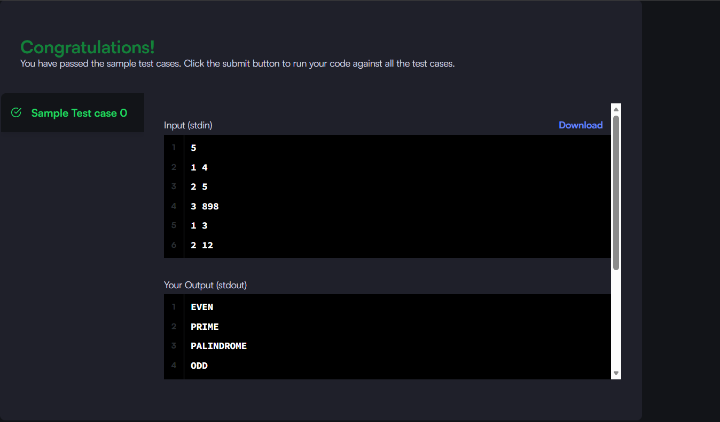

1B: Java Comparator

PROGRAM:
import java.util.*;
class Player {
String name;
int score;
Player(String name, int score) {
this.name = name;
this.score = score;
}
}
class Checker implements Comparator<Player> {
@Override
public int compare(Player a, Player b) {
if (a.score != b.score) {
return Integer.compare(b.score, a.score);
}
return a.name.compareTo(b.name);
}
}
public class Solution {
public static void main(String[] args) {
Scanner sc = new Scanner(System.in);
int n = sc.nextInt();
Player[] players = new Player[n];
for (int i = 0; i < n; i++) {
String name = sc.next();
int score = sc.nextInt();
players[i] = new Player(name, score);
}
Arrays.sort(players, new Checker());
for (Player p : players) {
System.out.println(p.name + " " + p.score);
}
sc.close();
}
}
OUTPUT:
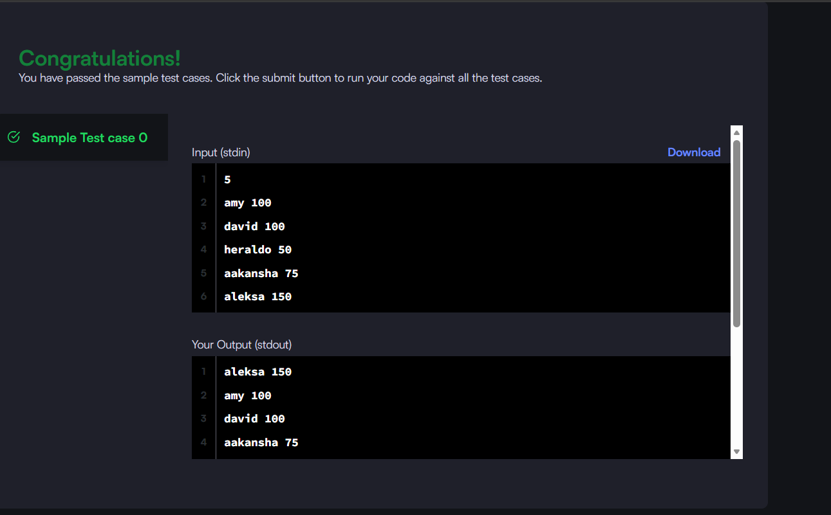

TASK2: Lambda Expressions
PROGRAM:
import java.util.*;
class Student {
private int id;
private String name;
private double cgpa;
public Student(int id, String name, double cgpa) {
this.id = id;
this.name = name;
this.cgpa = cgpa;
}
public int getId() {
return id;
}
public String getName() {
return name;
}
public double getCgpa() {
return cgpa;
}
}
class Checker implements Comparator<Student> {
public int compare(Student a, Student b) {
if (Double.compare(a.getCgpa(), b.getCgpa()) != 0) {
return Double.compare(b.getCgpa(), a.getCgpa());
} if (!a.getName().equals(b.getName())) {
return a.getName().compareTo(b.getName());
}
return Integer.compare(a.getId(), b.getId());
}
}
public class Solution {
public static void main(String[] args) {
Scanner sc = new Scanner(System.in);
int n = sc.nextInt();
List<Student> students = new ArrayList<>();
for (int i = 0; i < n; i++) {
int id = sc.nextInt();
String name = sc.next();
double cgpa = sc.nextDouble();
students.add(new Student(id, name, cgpa));
}
Collections.sort(students, new Checker());
for (Student student : students) {
System.out.println(student.getName());
}
sc.close();
}
}
OUTPUT:
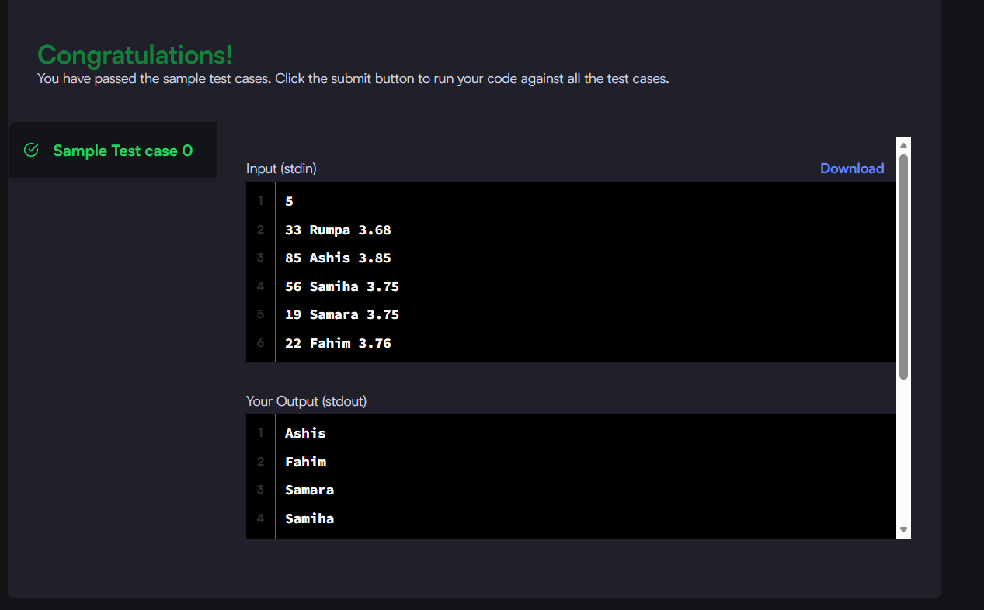

TASK3: Anonymous Functions & Functional Interfaces
3A: Sorting: Comparator
import java.util.*;
class Player {
String name;
int score;
Player(String name, int score) {
this.name = name;
this.score = score;
}
}
class Checker implements Comparator<Player> {
@Override
public int compare(Player a, Player b) {
if (a.score != b.score) {
return Integer.compare(b.score, a.score);
}
return a.name.compareTo(b.name);
}
}
public class Solution {
public static void main(String[] args) {
Scanner sc = new Scanner(System.in);
int n = sc.nextInt();
Player[] players = new Player[n];
for (int i = 0; i < n; i++) {
String name = sc.next();
int score = sc.nextInt();
players[i] = new Player(name, score);
}
Arrays.sort(players, new Checker());
for (Player p : players) {
System.out.println(p.name + " " + p.score);
}
sc.close();
}
}
OUTPUT:
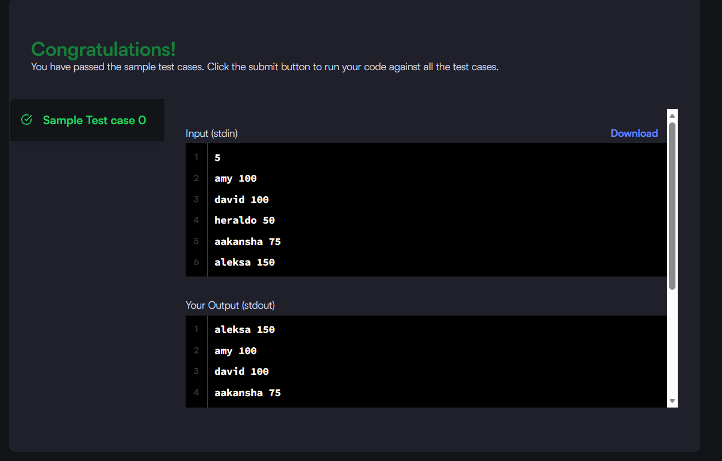

TASK4: Higher-Order Functions
4A: Running Sum of 1D Array
PROGRAM:
class Solution {
public int[] runningSum(int[] nums) {
for (int i = 1; i < nums.length; i++) {
nums[i] = nums[i] + nums[i - 1];
}
return nums;
}
}
OUTPUT:
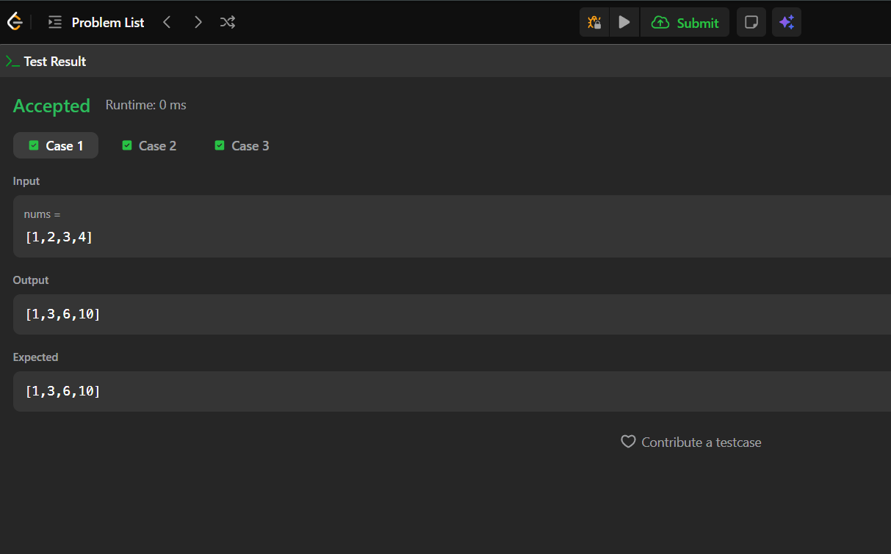
4B: Richest Customer Wealth
PROGRAM:
class Solution {
public int maximumWealth(int[][] accounts) {
int maxWealth = 0;
for (int i = 0; i < accounts.length; i++) {
int sum = 0;
for (int j = 0; j < accounts[i].length; j++) {
sum += account;}
maxWealth = Math.max(maxWealth, sum);
}
return maxWealth;
}
}
OUTPUT:
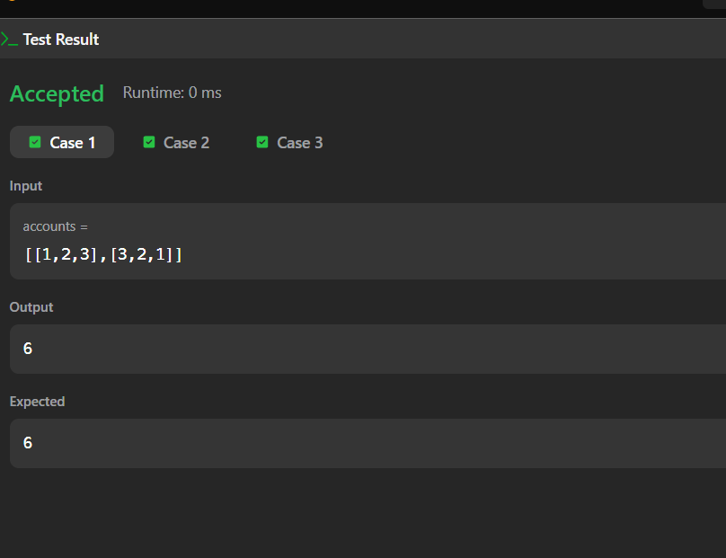
TASK5: Higher-Order Functions
5A: Squares of a Sorted Array
PROGRAM:
class Solution {
public int[] sortedSquares(int[] nums) {
int n = nums.length;
int[] ans = new int[n];
int left = 0;
int right = n - 1;
int index = n - 1;
while (left <= right) {
if (Math.abs(nums[left]) > Math.abs(nums[right])) {
ans[index] = nums[left] * nums[left];
left++;
} else {
ans[index] = nums[right] * nums[right];
right--;
}
index--;
}
return ans;
}
}
OUTPUT:
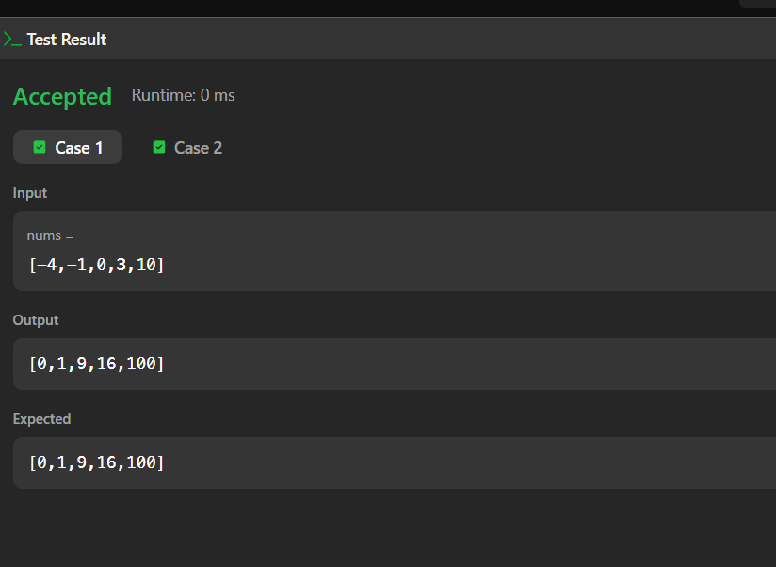
5B: Find Pivot Index
PROGRAM:
class Solution {
public int pivotIndex(int[] nums) {
int total = 0;
for (int num : nums) {
total += num;
}
int leftSum = 0;
for (int i = 0; i < nums.length; i++) {
int rightSum = total - leftSum - nums[i];
if (leftSum == rightSum) {
return i;
}
leftSum += nums[i];
}
return -1;
}
}
OUTPUT:
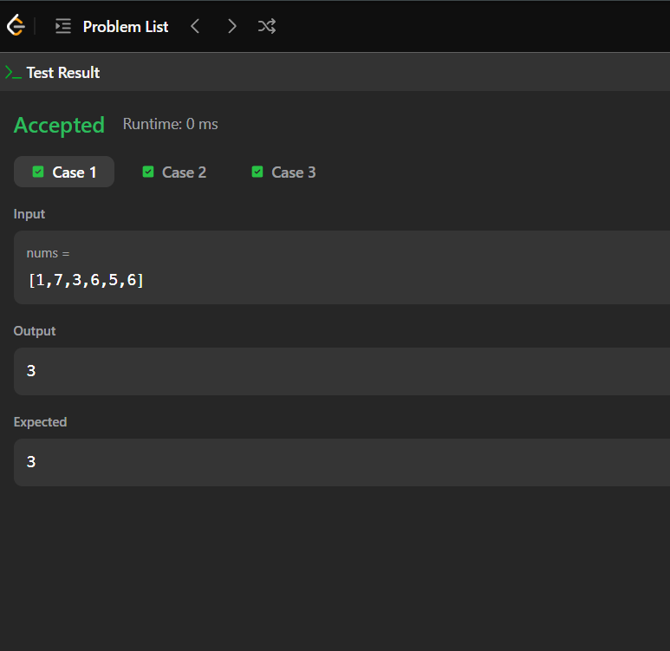
RESULT: Thus the week 1 task has completed and executed successfully.

